**steps:**

**Step 1:** Click on the **Legend**option. A drop-down appears. We have multiple options available here i.e. **Options**, **Text**, and **Title**. We can set the **position**of the legends. Using the **Text**property, we can **change**the color and **font size** of the legends i.e. **Department**. Click on the **Title**, to customize the title i.e. **Department**.

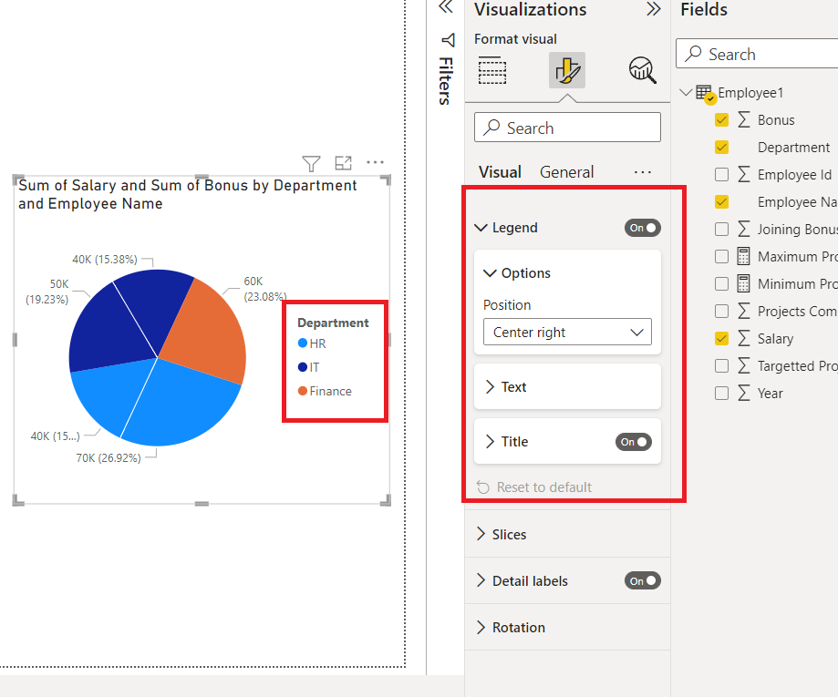

**Step 2:**Click on the **Options**property, and a drop-down appears. We can set the **position**of the legends accordingly. For example, to**Top Center,** **Bottom left,** etc. By default, the**Top left** is the position.

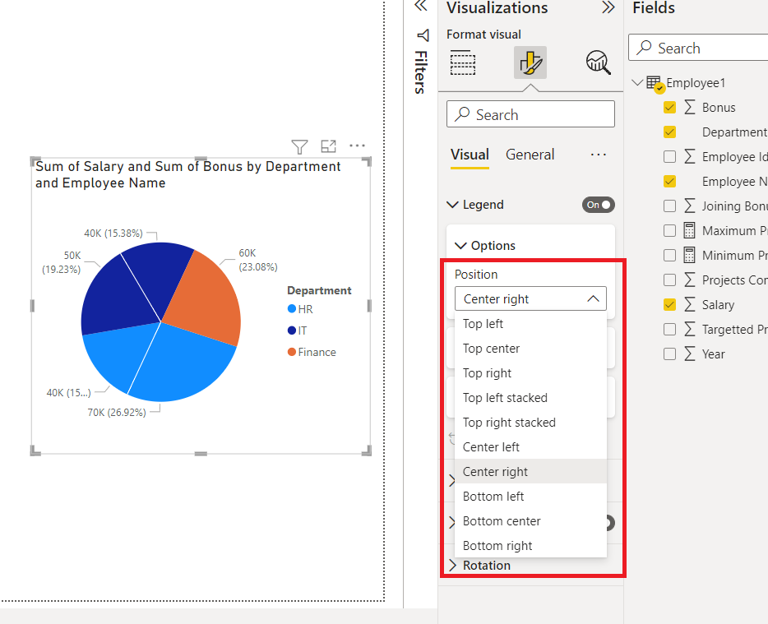

**Slices**

**Slices**refer to similar groups’ data values either as a **legend**or as a **value**. Click on the **slices**option. A drop-down appears. We have **one** option i.e. **Color**. We can customize the color of the **slices**accordingly.

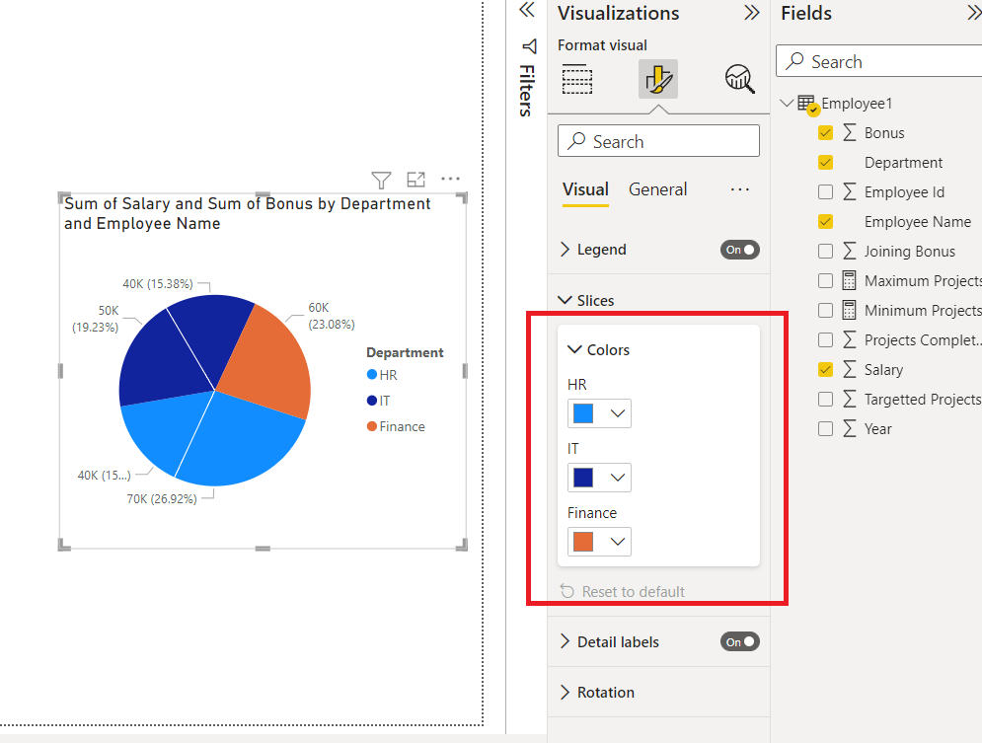

**Detail Labels**

**Detail labels** provide additional information on the slices of the pie chart. For example, **Arushi**and **Gautam**have a **salary**of **50K**and **40K**, and they want to display that on the slices. Click on the**Detail labels** option. The **salary**detail label will be added to the entire chart. **Salary**is added because while creating the chart, we have added **salary**in the **details**option.  Also, a drop-down appears. We have **two**options i.e. **Options**, and **Values**.

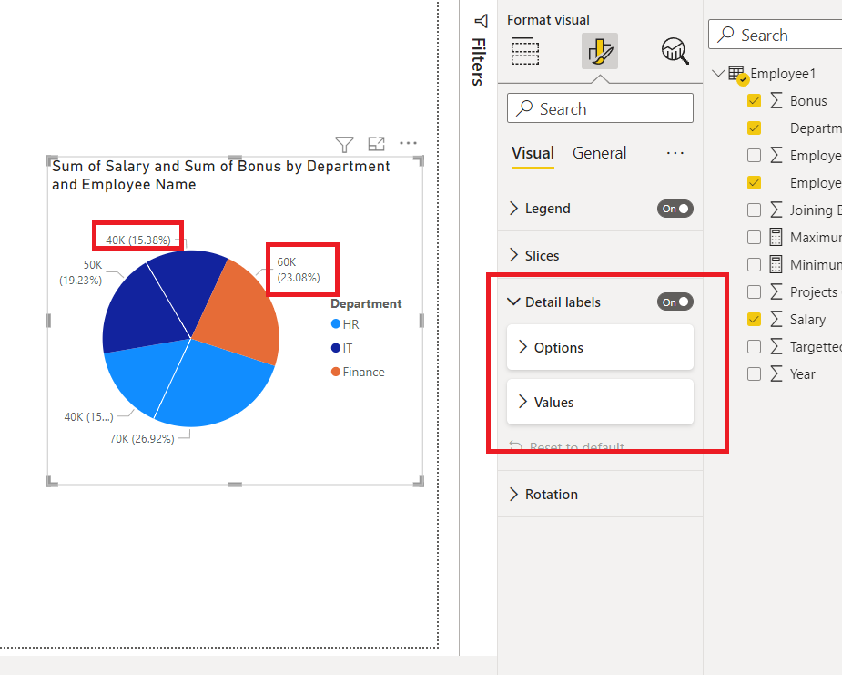

**The following are the steps:**

**Step 1:**Click on the **Options**property. We can set the **position**of the detail labels, **to inside**, **outside**, **preferably outside**, etc. We can also set the **Label Contents**, **to a data value**, **percent of the total,**etc.

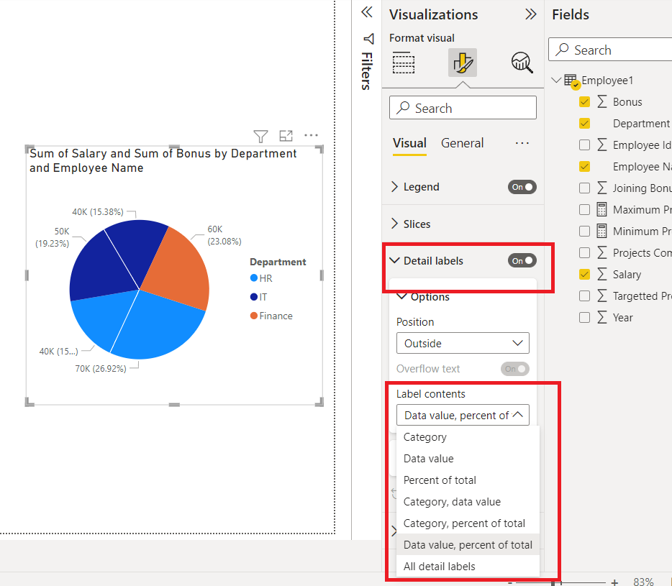

**Step 2:**Click on the **Values**property. We can set the **color**of the detail labels, change their **font**type, and can also change the **size**of the detail labels.

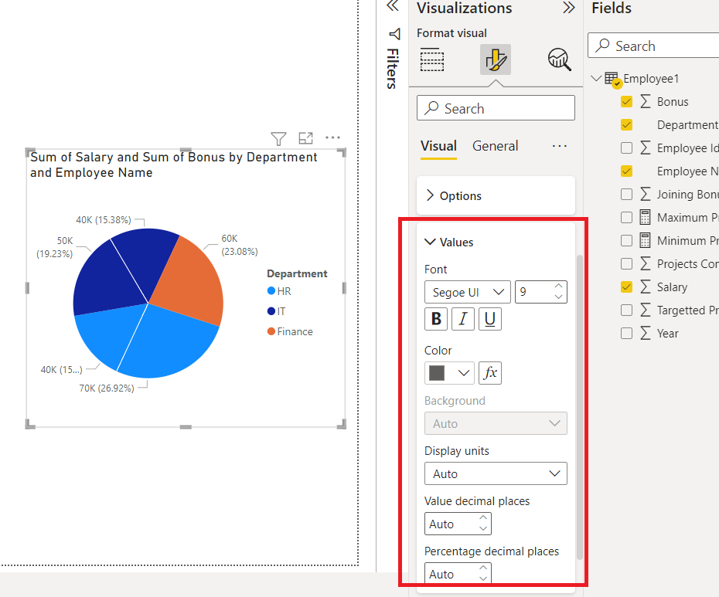

**Rotation**

The rotation is used to change the orientation, of the pie chart.

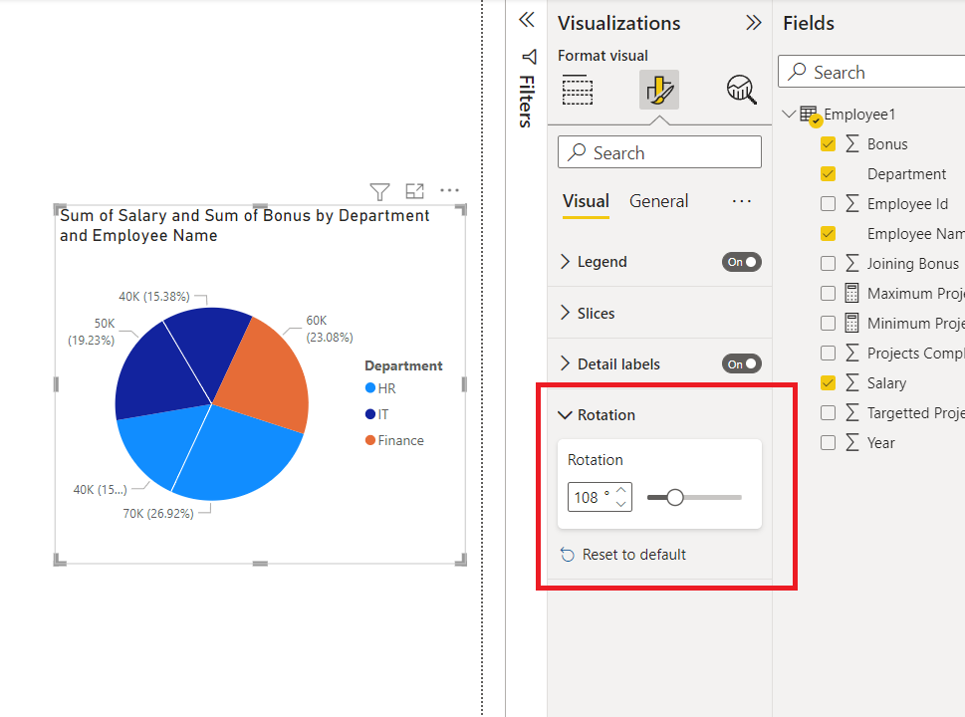

**The following are the steps:**

**Step 1:** Click on the **rotation** option. We can rotate the pie chart. See the gif below.



**General Formatting**

There are multiple options in **general formatting**. For a pie chart, we have options like **Title**, **tooltip**, **effects**, **alt text**, etc. We will look at each of the options in detail.

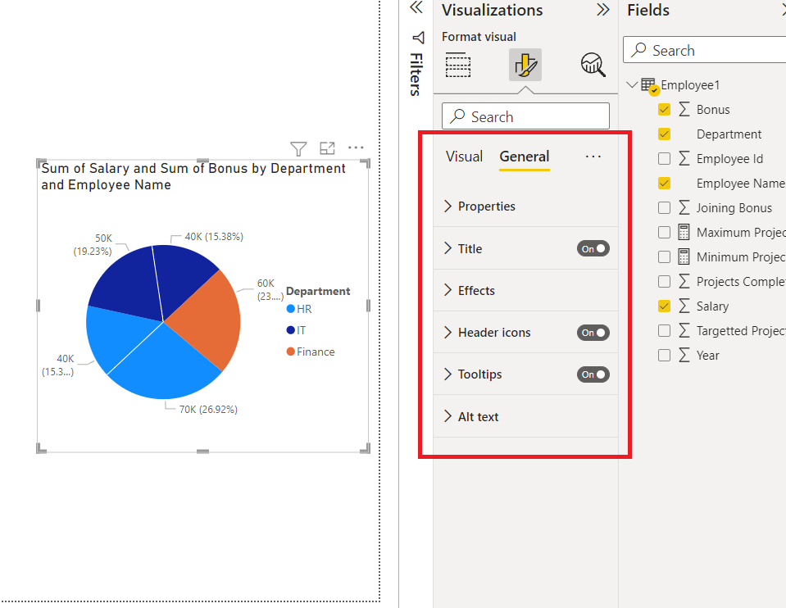

**Property**

The property option is generally present in every visualization. It contains**three** options, **Size**, **position**, and **Advance** options. We, generally do not use these properties, because all are easily accessible with **mouse clicks**. The **size** property helps to resize the visualization created. The **position** property changes the position of the visualization, in the report. The **Advance option** comprises adding a **layer order**, which is rarely used.

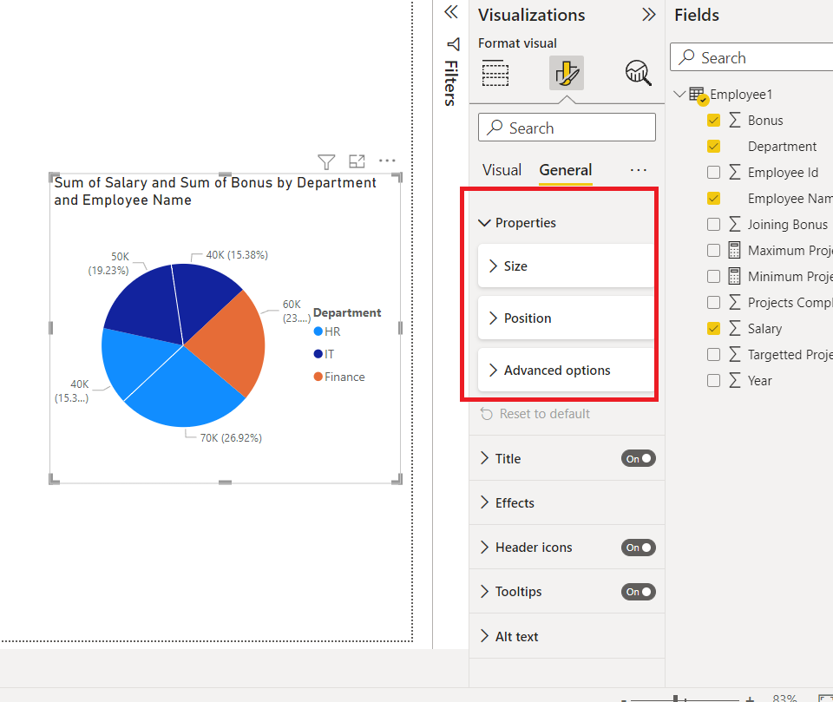

**Title**

The **title** formatting is present in every visualization. As the name suggests, it adds a **heading** to the visualization. Click on the **slider** to enable the title.

**The following are the steps:**

**Step 1:** Click on the **Title** option. A drop-down list appears. Add the **title**, under the **Text** section. For example, the **Sum of Salary by Employee Name** **and Department**. We can view in the image a **title** is added to the chart. As done previously we can customize the **size**, **font type**of the chart, etc.

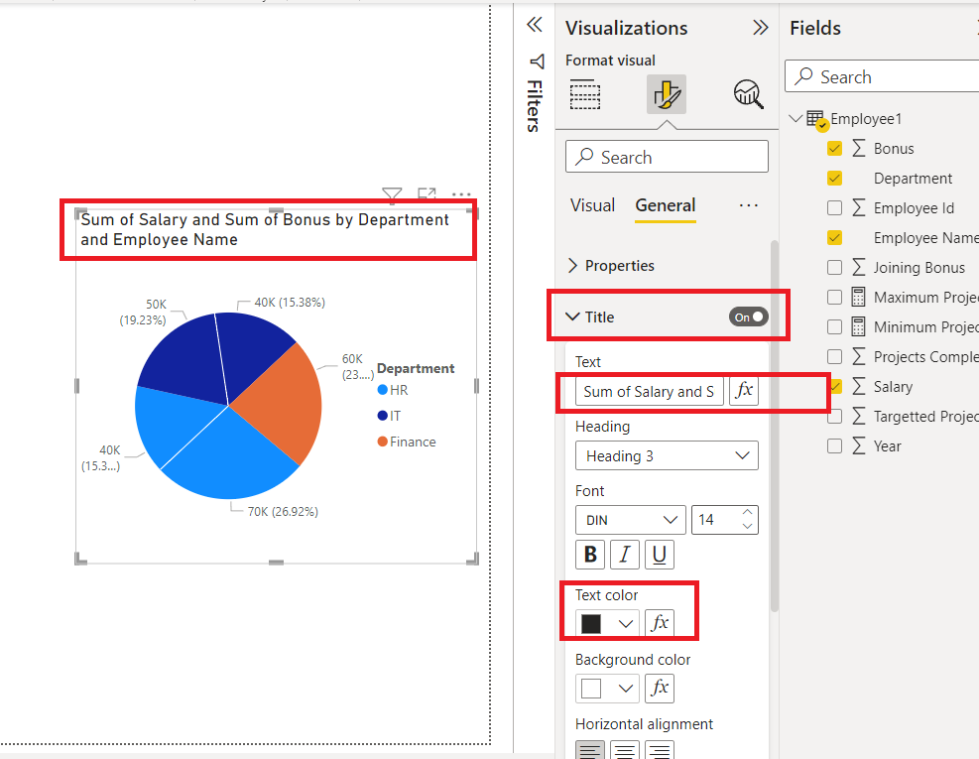

**Step 2:**We can also change the **color**of the title. Under the **text**color, select the required color. For example, **yellow**in this case. The **title**color changes to **yellow**.

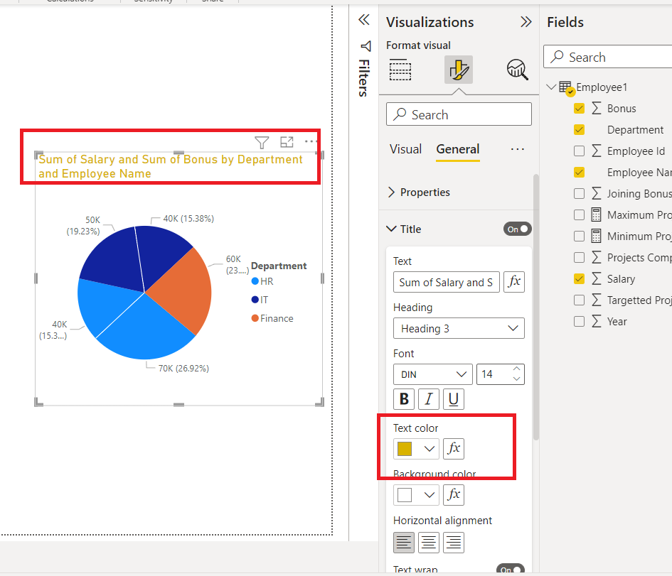

**Effects**

The **effects** section comprises **three** features i.e. **Background**, **Visual Border**, and **Shadow**. All the mentioned properties work according to their names. The **background** adds a**background color** to the visualization, the **Visual border** adds a border around the visualization, and the**shadow option**creates a shadow on the outskirts of the visualization.

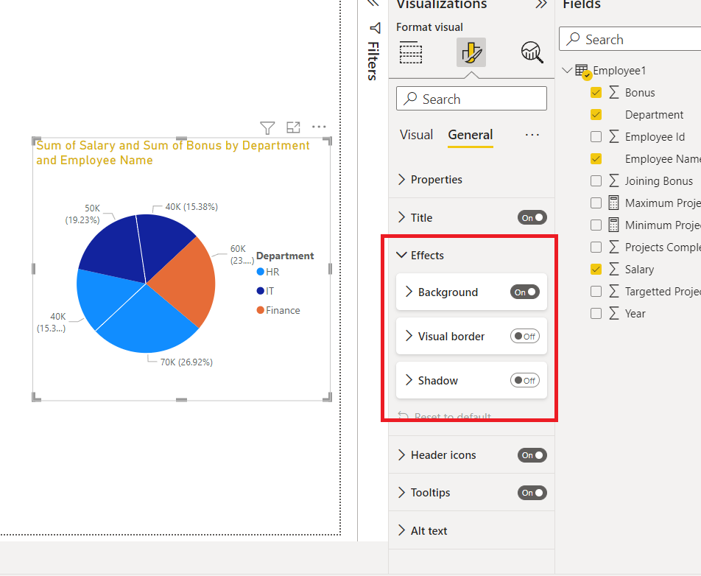

**The following are the steps:**

**Step 1:**Click on the **Background** option. Select the **color** of the background accordingly. For example, **Pink**. We can view in the below image that the background of the chart changed to **pink**.

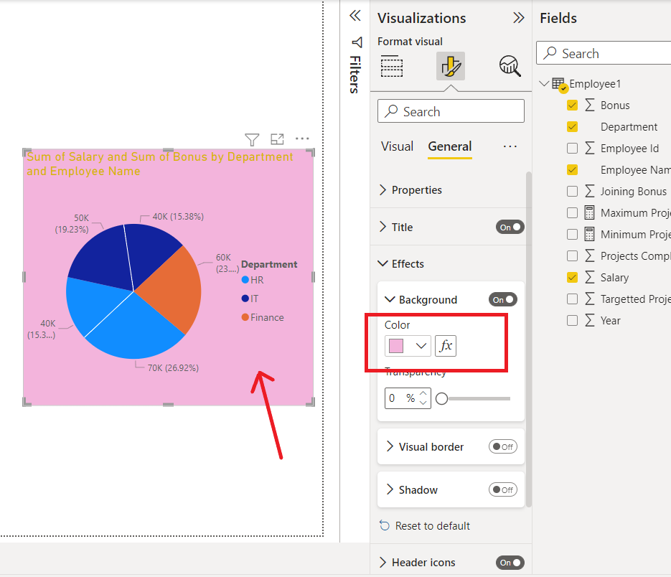

**Header Icons**

**Header icons** are the options, present on the top of the visualization. For a **pie** chart, there are **two** options,**filter on visuals**and **more options.** Click on the **header-icons** option, we will get various options, like **Background**, **Border**, and **Icons**. One can set its colors as per choice.

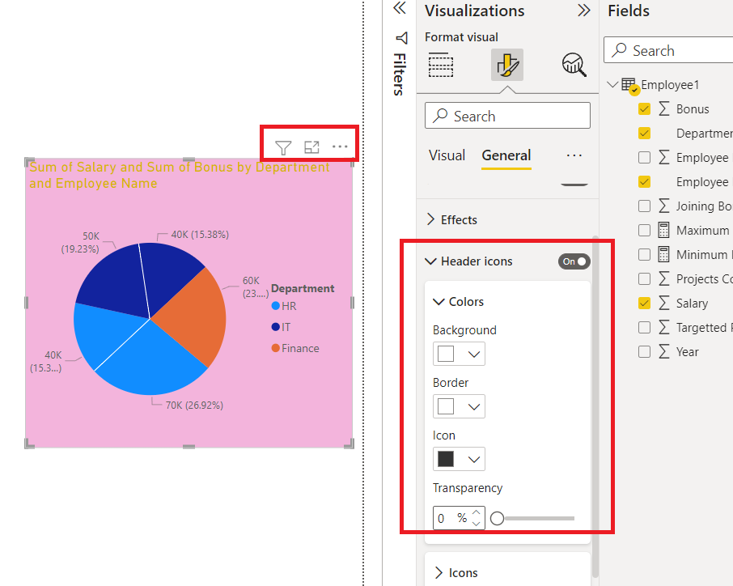

**Tooltips**

If we **hover** over a visualization, then we cannot view any information related to the chart. Consider a situation, where we want to display the fields added by hovering over the chart, then this task can be achieved by the **Tooltips** option. **Tooltips** have **three** properties i.e. **Options**, **Text**, and **Background**. Click on the **tooltips** option. Now, for example, we **hover** over a slice, then we can view that the **employee Name Arushi**, **Department IT**, **Salary 50K,**and **Bonus 20K**is displayed. We can set **text** and **background** **color** according to our needs.

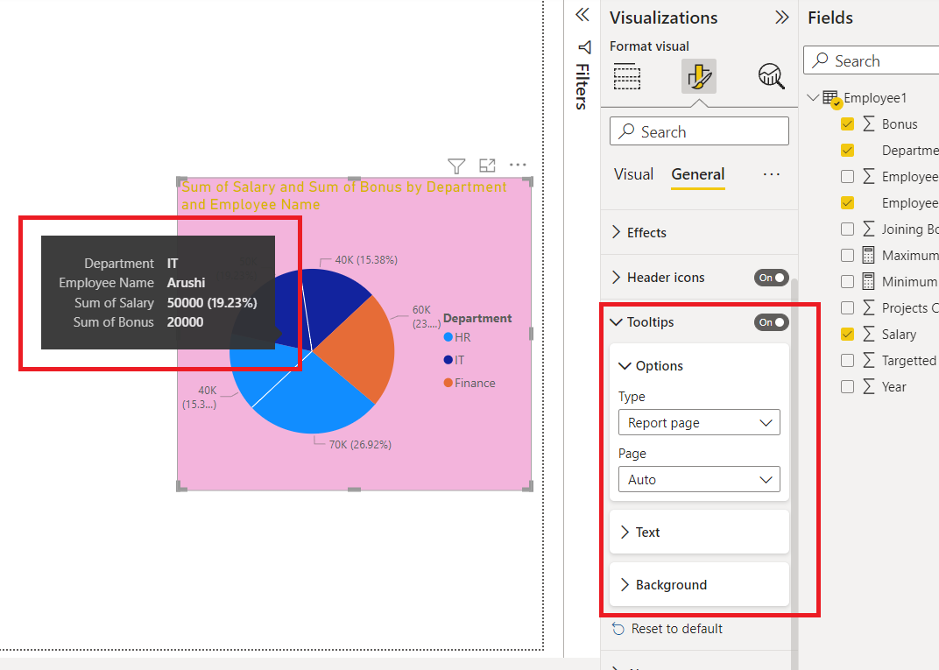

**Alt Text**

**Alt text** is a property present in each visualization. People generally misinterpret,**alt text** by its name, they think that alt text will be displayed when they hover over the visualization. Alt text is for the persons, who cannot see the visuals, images, etc. This option is only available if you are using a **narrator** in your system. When your narrator is active, then this alt text will be spoken by the system. Click on the **Alt text**, and type the required text.

